*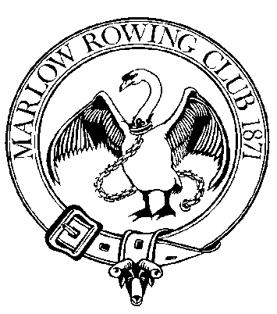Marlow Rowing Club*

**Junior Rowing Squads Fob Allocation**

September 2015

Dear Junior Member,

By reading this document you are confirming your agreement to abide by the regulations associated with the allocation of a fob to you for access into the Club, **during** **normal Junior training times**. Please note that you will be required to provide a **£5.00** deposit (this is refundable on surrender of your fob), on collection of your fob. In addition please be aware that your individual fob will be programmed to allow access during these times only. It is also programmed to give you access to two doors only; the front door and the door through to the changing rooms and gym.

With the allocation of this fob comes some responsibility for helping to maintain the security of our building. Therefore please be aware that you are required to adhere to the following rules and regulations:

* Do not lend your fob to anyone. It is your responsibility and should it be used by others you will be asked to return it.
* Do not give access (hold the door open, or activate a keypad) to any adult except coaches whom you know and recognise. Any adult, including parents, who is given access to the gym or changing room areas, without prior permission, is in breach of Child Safety regulations which is a prosecutable offense so please do not place anyone in that position however good your intentions. If a parent needs to speak with their child, please take a message/go and find the person concerned or speak with a coach.
* You many only give access (hold the door open, or activate a keypad) to other Juniors whom you know and recognise.
* If you misplace or lose your fob please you must inform your coach or Caroline Taylor ([js@marlowrowingclub.org.uk](mailto:js@marlowrowingclub.org.uk)) or the Membership Secretary David Plaskett ([membership@marlowrowingclub.org.uk](mailto:membership@marlowrowingclub.org.uk)) **IMMEDIATELY**. Your fob can then be deactivated and the building security maintained and a new fob organised, should you wish it.
* Under the terms of our agreement with Sport England we are required to record the footfall into the club. Therefore please endeavour to activate one of the two ‘monitor’ pads which display the Marlow Rowing Club Logo, located immediately opposite the front door and next to the hose reel by boat bay 1, every time you come to the club.

Please understand that a record of your fob use is being maintained and that the building is fitted with security cameras therefore if any incident occurs while it is recorded that you are in the building you are liable to be asked to assist with any investigation taking place.